***Project Report***

***Name: Gajal Sharma***

***College: Poornima University, Jaipur***

***Project Title: Detection of Road Lane Lines***

***Internship: Data Science & AI - 2025***

***Submitted To: Pinnacle Labs***

*“””*

***Objective****:*

*The goal of this project is to detect road lane lines from images using Python and OpenCV.*

*This technique is essential in the field of autonomous vehicle navigation, where identifying and following*

*Lane boundaries ensures safe and accurate driving assistance.*

*In this project, we:*

*1. Read a road image using OpenCV.*

*2. Convert it to grayscale.*

*3. Apply Canny edge detection.*

*4. Use Hough Line Transform to detect lane lines.*

*5. Display the final image with lane lines highlighted in green.*

*“””*

***Tools and Libraries Used:***

*• Python 3*

*• OpenCV*

*• NumPy*

*• Google Colab (for running code)*

***Python code***

*Import cv2*

*Import numpy as np*

*From google.colab.patches import cv2_imshow*

*# Read the image*

*Img = cv2.imread(“lane.jpg”)*

*Gray = cv2.cvtColor(img, cv2.COLOR_BGR2GRAY)*

*# Detect edges*

*Edges = cv2.Canny(gray, 50, 150)*

*# Detect lines*

*Lines = cv2.HoughLinesP(edges, 1, np.pi/180, 100, minLineLength=100, maxLineGap=10)*

*# Draw lines on original image*

*If lines is not None:*

*For line in lines:*

*X1, y1, x2, y2 = line[0]*

*Cv2.line(img, (x1, y1), (x2, y2), (0, 255, 0), 3)*

*# Show result*

*Cv2_imshow(img)*

***Output****:*

*The image output shows detected lane lines highlighted in green.*

*These lines were detected using edge detection and the Hough Line Transform technique.*

***“””***

***Conclusion:***

*This project demonstrates the ability to detect lane lines in real-world images*

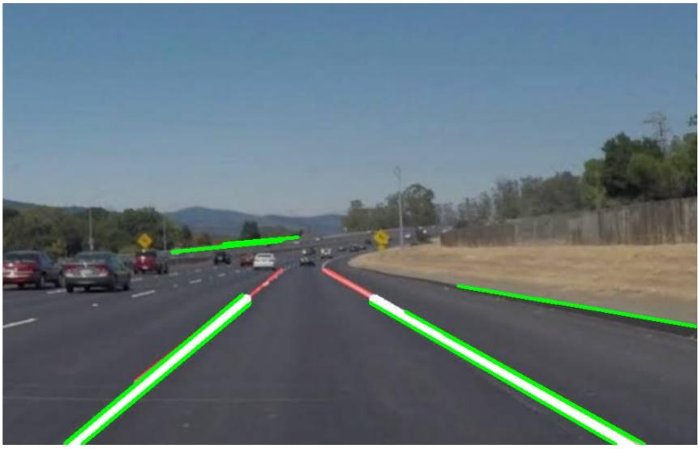

**Output getted**